**NAME** :- Manish Shashikant Jadhav

**UID** :- 2023301005.

**BRANCH** :- Comps -B. **BRANCH:** B.

**EXPERIMENT 3: Implement various String Operations in 8086 through the utilities provided by DOS interrupts (MASM).**

**SUBJECT** :- CAO (COMPUTER ARCHITECTURE AND ORGANIZATION)

**TOPIC 1** :- IF STRINGS ARE NOT EQUAL.

**CODE** :-

data segment

str1 db "coalab","$"

str3 db "The provided strings are Equal","$"

str4 db "The provided strings are Not Equal","$"

data ends

extra segment

str2 db "caolab","$"

extra ends

code segment

assume cs:code, ds:data, es:extra

start:

mov ax,data

mov ds,ax

mov ax,extra

mov es,ax

mov di,ax

lea si, str1

lea di, str2

mov cx,06h

cld

repe cmpsb

jnz notequal

lea dx,str3

mov ah,09

int 21h

jmp terminate

notequal:

lea dx, str4

mov ah,09

int 21h

terminate:

mov ah,4ch

int 21h

code ends

end start

**OUTPUT** :-

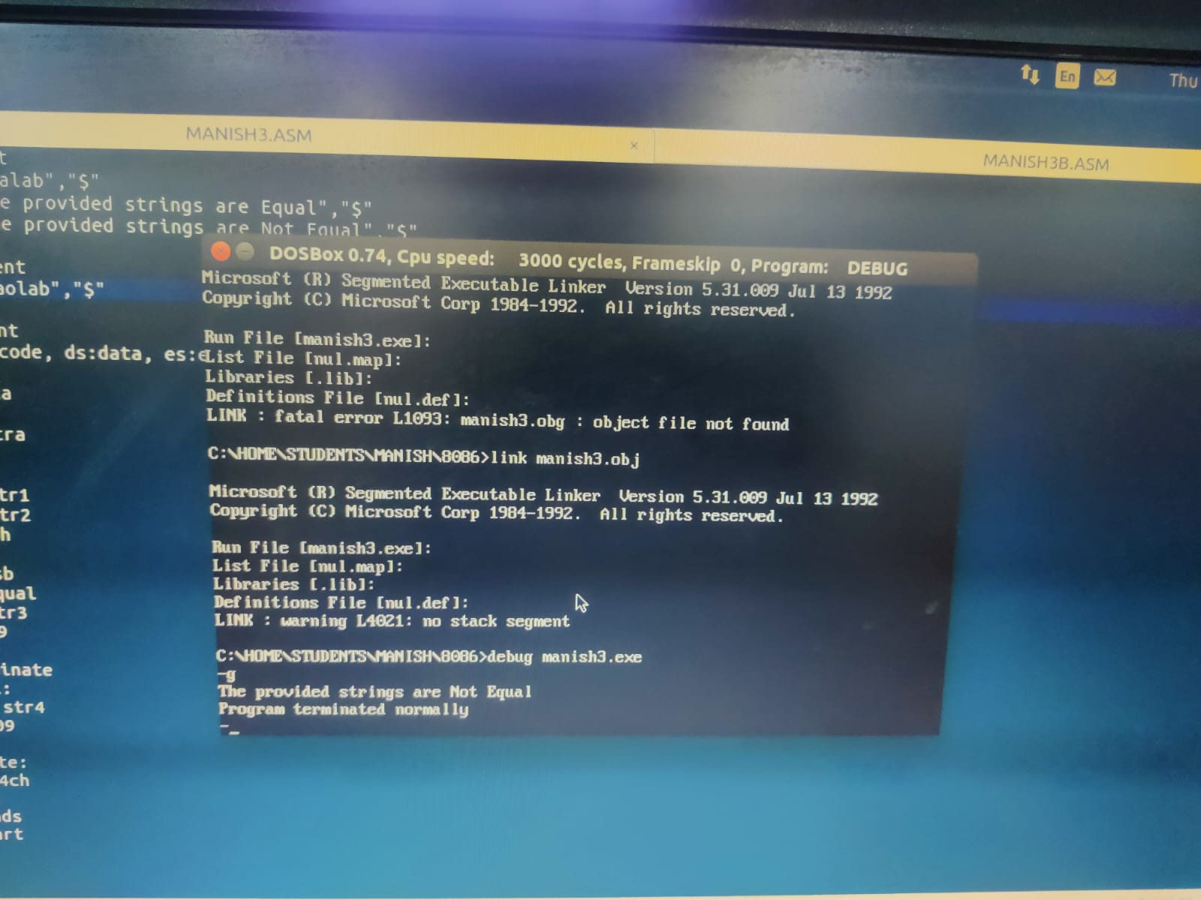

**TOPIC 2** :- IF STRINGS ARE EQUAL.

**CODE** :-

data segment

str1 db "coalab","$"

str3 db "The provided strings are Equal","$"

str4 db "The provided strings are Not Equal","$"

data ends

extra segment

str2 db "coalab","$"

extra ends

code segment

assume cs:code, ds:data, es:extra

start:

mov ax,data

mov ds,ax

mov ax,extra

mov es,ax

mov di,ax

lea si, str1

lea di, str2

mov cx,06h

cld

repe cmpsb

jnz notequal

lea dx,str3

mov ah,09

int 21h

jmp terminate

notequal:

lea dx, str4

mov ah,09

int 21h

terminate:

mov ah,4ch

int 21h

code ends

end start

**OUTPUT** :-

